Backwoods regional library system

Test scenario: Borrowing Restricted

## Scenario Description:

* This scenario is related with the use case: Borrow Book which basically describes how the member are restricted from borrowing the book once they met the condition.
* This test scenario covers use case “Borrow Book”.
* It comes into the act automatically whenever the user has reached the limitation from borrowing of the book in any steps of the use case and thus preventing the use case ‘borrow book’ from completion.

**Version History**

|  |  |  |  |
| --- | --- | --- | --- |
| **Version** | **Date** | **Description** | **Author** |
| 1.0 | 1/10/2016 | Initial version | KAMAL RAJ KANDEL |

## Test Scripts

The following scripts will cover this scenario:

* if the user has borrowed more than 5 books. (TS01_01).
* if the user has the overdue loans. (TS02_02).
* if the user fine is at least $10 or more. (TS03_03).
* if the borrower wants to borrow the book which is already borrowed by someone(TS04_04).

## Use Case Name

* The use case ‘Borrow Book’ is covered by this scenario.

## Description: Borrow Book

* Normally this use borrow book begins when the member wants to borrow the book by pressing the Borrow Books button on the system. As a result, the system will activate the card scanner to enable the user to scan the card. Once the user scan and if there is no restriction on the account then the user is allowing to borrow the books as their wish.

## Actor:

* User having the valid library member card.

## Pre conditions:

* Borrower must have the valid library member card.
* There should not be any restriction like fines, overdue or no. of book limit reached etc.
* Book that the member wants to borrow should have the valid bar code and should be available.

## Normal Flow

The use case begins when the borrower takes their selected books to the self service station

|  |  |
| --- | --- |
| Actor | System |
| 1 The borrower clicks the borrow book function. | 2 The system enables the member to scan their member ship card. |
| 3 The borrower scans the member ship card. | 4 The system validates the card and check record |
|  | 5 The system activates the book scanner. |
|  | 6 The system displays the borrower details. |
|  | 7 The system displays the member existing loan details if exist. Otherwise just display the empty window. |
| 8 The borrower scans a book. | 9 The system displays the book’s details. |
|  | 10 The system adds the book to the pending loan list. |
| 11 The borrower indicates they have completed scanning their books. | 12 The system display’s the pending loan list for confirmation. |
| 13 The borrower confirms the pending loan list. | 14 The system records the loans, and adds them to the borrower’s record of current loans. |
|  | 15 The system prints a receipt for the loan indicating the due date to return. |

The use case ends

Borrowing Restriction Apply:

In the above flow of events the borrowing restriction may apply after step 4. There are no of condition for the borrowing restriction which are listed below:

* What happens if the borrower has reached the maximum number of borrowed items?

As soon as the actor swipes the card the system displays the borrowing restricted screen indication that the maximum number of borrowed item has been reached.

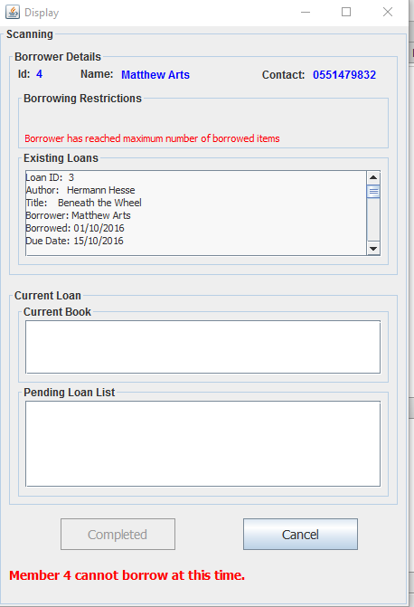

Then the user cancels the borrowing book process by pressing Cancel and the use case terminates.

* What happens if the borrower has overdue loans?

As soon as the actor swipes the card the system displays the borrowing restricted screen indication that the borrower has overdue loans.

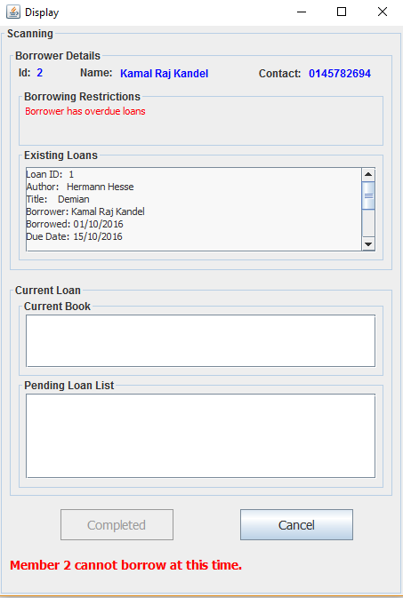

Then the user cancels the borrowing book process by pressing Cancel and the use case terminates.

* What happens if the borrower has exceeded fine?

As soon as the actor swipes the card the system displays the borrowing restricted screen indication that the borrower has fine owing $10.

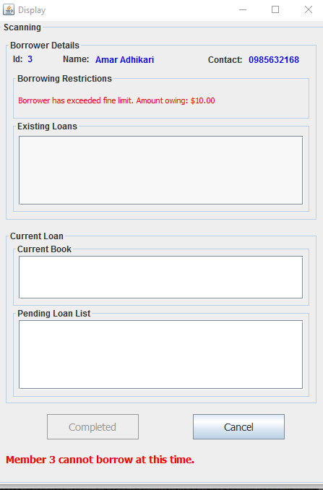

Then the user cancels the borrowing book process by pressing Cancel and the use case terminates.

* What happens if the borrower wants to borrow the book which is not available?

As soon as the user enter the barcode at step 8 then the system displays the message saying that the Book is not available.

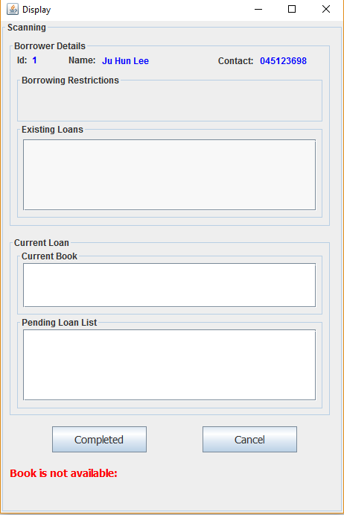

As soon as the above screen is displayed the system prompts the user to scan the books more books or the user can terminate the process if they wish by simply clicking the cancel Button. If they want to scan more books, then the use case begins from step 9.

# 

# Test script

**Version History**

|  |  |  |  |
| --- | --- | --- | --- |
| **Version** | **Date** | **Description** | **Author** |
| 1.0 | 1/10/2016 | Initial version | KAMAL RAJ KANDEL |

## The following test script were evaluated to test the Borrow Restricted test case.

## 

|  |  |
| --- | --- |
| **Test ID:** | **TS01_01** |
| **Test Name:** | Test what if the user has reached maximum number of borrowed items |
| **Use Case Tested:** | Borrow books |
| **Test Description:** | Test how the system responds when the user borrowed more than 5 books. |
| **Pre-conditions:** | The user must enter the member id and must have borrowed 5 books. |
| **Post-conditions:** | System display the existing loan details and display the message you cannot borrow the book at this time. |
| **Notes:** | The member id should be correct. |
| **Result**  **(Pass/ Fail/ Warning/ Incomplete)** |  |

|  |  |  |  |  |
| --- | --- | --- | --- | --- |
| **Step Number** | **Test Step** | **Expected Test Results** | **Pass** | **Fail** |
| **1.** | User click on borrow books. | System display the card reader forum. |  |  |
| **2.** | User with member id 4 swipes the card | System display the existing loan history with a message that you cannot borrow the book at this time. |  |  |

|  |  |
| --- | --- |
| **Test Data Table** | |
| No. of test | 1 |
| For Member ID | 4 |

# 

# Result On the Screen



|  |  |
| --- | --- |
| **Test ID:** | **TS02_02** |
| **Test Name:** | Test what if the user has overdue loans. |
| **Use Case Tested:** | Borrow books |
| **Test Description:** | Test how the system responds when the user has the overdue loans. |
| **Pre-conditions:** | The user must enter the member id and must have overdue loans. |
| **Post-conditions:** | System display the existing loan details and display the message you cannot borrow the book at this time. |
| **Notes:** | The member id should be correct. |
| **Result**  **(Pass/ Fail/ Warning/ Incomplete)** |  |

|  |  |  |  |  |
| --- | --- | --- | --- | --- |
| **Step Number** | **Test Step** | **Expected Test Results** | **Pass** | **Fail** |
| **1.** | User click on borrow books. | System display the card reader forum. |  |  |
| **2.** | User with member id 2 swipes the card | System display the existing loan history with a message that you cannot borrow the book at this time. |  |  |

|  |  |
| --- | --- |
| **Test Data Table** | |
| No. of test | 1 |
| For Member ID | 2 |

# 

# Result On the Screen



|  |  |
| --- | --- |
| **Test ID:** | **TS03_03** |
| **Test Name:** | Test what if the user has fine of 10$ or more. |
| **Use Case Tested:** | Borrow books |
| **Test Description:** | Test how the system responds when the user has fine$10 or more. |
| **Pre-conditions:** | The user must enter the member id and must have fine of at least 10$. |
| **Post-conditions:** | System display the existing loan details and display the message you cannot borrow the book at this time. |
| **Notes:** | The member id should be correct. |
| **Result**  **(Pass/ Fail/ Warning/ Incomplete)** |  |

|  |  |  |  |  |
| --- | --- | --- | --- | --- |
| **Step Number** | **Test Step** | **Expected Test Results** | **Pass** | **Fail** |
| **1.** | User click on borrow books. | System display the card reader forum. |  |  |
| **2.** | User with member id 3 swipes the card | System display the existing loan history with a message that you cannot borrow the book at this time. |  |  |

|  |  |
| --- | --- |
| **Test Data Table** | |
| No. of test | 1 |
| For Member ID | 3 |

# 

# Result On the Screen



|  |  |
| --- | --- |
| **Test ID:** | **TS04_04** |
| **Test Name:** | Test if the borrower wants to borrow the book which is already borrowed by someone. |
| **Use Case Tested:** | Borrow books |
| **Test Description:** | Test how the system responds when the user wants to borrow the book which is already borrowed by someone. |
| **Pre-conditions:** | The user must enter the valid member id with no any fines, overdue or borrow limitation number with correct barcode of the book. |
| **Post-conditions:** | System display message that the book is not available. |
| **Notes:** | The member id and barcode should be correct. |
| **Result**  **(Pass/ Fail/ Warning/ Incomplete)** |  |

|  |  |  |  |  |
| --- | --- | --- | --- | --- |
| **Step Number** | **Test Step** | **Expected Test Results** | **Pass** | **Fail** |
| **1.** | User click on borrow books. | System display the card reader forum. |  |  |
| **2.** | User with member id 4 swipes the card | System activate the book scanner forum. |  |  |
| **3.** | User enter the barcode. | System display the book is not available. |  |  |

|  |  |
| --- | --- |
| **Test Data Table** | |
| No. of test | 1 |
| For Member ID | 1 |

# 

# Result On the Screen

